Field Science Course and Advanced Laboratory Course in 2018

1.1 Outline
“Field Science Course” aims to train students to do fieldwork on the UNESCO World Natural Heritage Site on Yakushima Island, Japan. Young students and scientists from abroad and graduate students in Kyoto University attend the course together, using English as an official language.
“Advanced Laboratory Course” aims to train students to do laboratory works, which is useful for field biology. In this course, various samples collected in the preceding “Field Science Course” will be analyzed. Students can choose a topic which is suitable for their interest and prior experience in laboratory works. Through the two courses, students will experience the whole process of scientific field research, sampling in the field, analyzing in the laboratory, conducting data analysis and presentation of the results.
No previous experience is required to take these courses and we welcome both students who engage in fieldwork and those who engage in laboratory work. We also welcome students who have few chances to communicate in English. Please communicate with foreign students of the same generation.
In the Field Science Course, students will learn the fundamental methods to study the ecology of wildlife. We stay in a small village, having local food. We hope you enjoy the nature and culture of Yakushima Island.

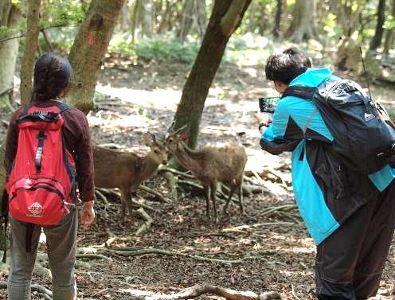 | 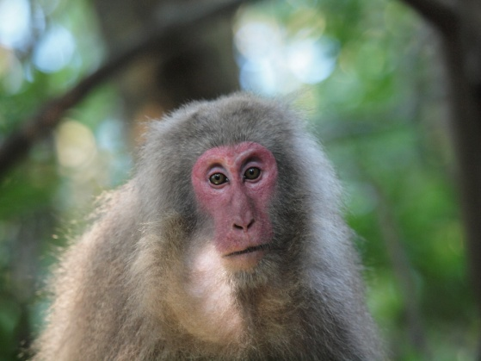 | 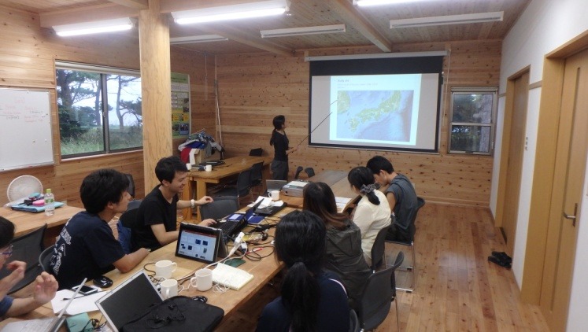
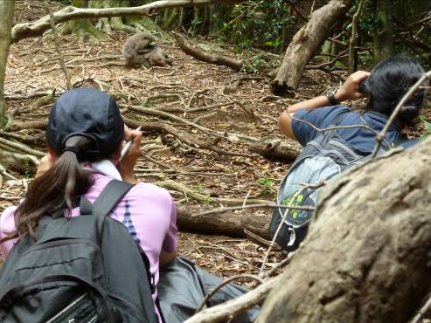 | 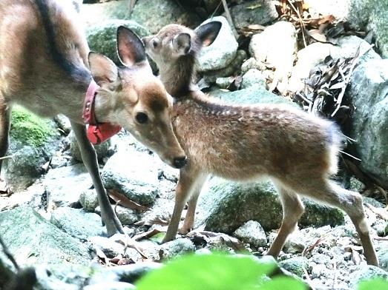 |  | 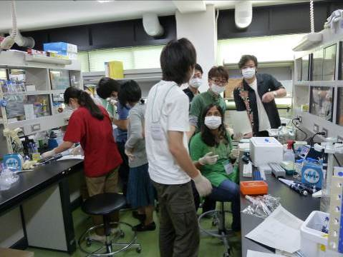

1.2 Application
A graduate student of Biological Science, Graduate School of Science, Kyoto University (as of October 1, 2018) can apply for the courses. Please note that we accept a limited number of participants due to safety for fieldwork and limited capacity of accommodation and transportation.
We will hold the course twice this year, in spring and fall. The contents of spring and fall courses are different, and students may take only one of them. If an applicant was unaccepted for the spring course, he/she may apply again for the fall course.
In both seasons, the Field Science Course will be held in Yakushima Island. We hold the Advanced Laboratory Course either at Yoshida Campus of Kyoto University in Kyoto City or at the Primate Research Institute in Inuyama City (depends on the group). Advanced Laboratory Course
Students may apply to either the Field Science Course or Advanced Laboratory Course, though we encourage you to take both of the courses.

Application form is available at the following site
http://www.wildlife-science.org/ja/curriculum/

1.3 Fee
Please pay about 17,000 yen for meals and insurance, on the first day. This will pay you back from the university about a month later. During the Field Science Course in Yakushima, please pay by yourself the cost of meals other than those provided in our field station (usually, lunch on the first day, lunch and dinner on the last day on the way to and back from Yakushima), and optional activities such as entrance fee of sightseeing sites (\300-500 / site), public bath (\200-500) and snacks.

2. Schedule

Field and Genome Science Courses in fall
August 31 Deadline for application by students of Kyoto University (both for the Field Science Course and Genome Science Course)
September 7 Fix the member and the courses

Field Science Course (Yakushima Island, Kagoshima Prefecture)
Nov 3 Field Science Course starts (Move to Yakushima on this date)
From Kyoto: 09：35 Kobe - 10：45 Kagoshima
12：55 Kagoshima - 13：35 Yakushima
(Flight schedule is not fixed)
From Inuyama: 900 Chubu Centrair - 1025 Fukuoka
1305 Fukuoka – 1405 Yakushima (Flight schedule is not fixed)
Nov 3-7 Fieldwork in Yakushima
Nov 8 Data analysis, presentation in the afternoon
Nov 9 Leave Yakushima (if we have time, we will visit some places in Yakushima)
To Kyoto: 18：00 Yakushima - 18：35 Kagoshima
19：55 Kagoshima - 21：00 Kobe
(Flight schedule is not fixed)
To Inuyama: 1705 Yakushima – 1740 Kagoshima
2025 Kagoshima – 2140 Chubu Centrair
(Flight schedule is not fixed)

Advanced Laboratory Course at Kyoto University (WRC, Kyoto or PRI, Inuyama)
Nov 12–16 Molecular experiments and analyses, at WRC, Kyoto / PRI, Inuyama.
In the latter part, we will prepare for the presentation of the results (both for Field and Laboratory Courses) in the international seminar at Kyoto University, Yoshida campus, Kyoto. In the seminar, invited speakers will also talk. We will have banquet in the evening.

3. Field Science Course in Fall

3.1 Participants
About 14 graduate students
About 6 teaching staff, including professors, post-doc and graduate students who study in Yakushima and/or subject species.

3.2 Groups
We form two groups: deer behavior and hormone, DNA (field genetics) group. Each group will engage in different tasks. Choose your preference of the groups, from first to second. Please note that we cannot ensure your first preference, due to limited capacity of each group.

A) Hormone (field endocrinology) group
Title
Sex steroid hormone concentrations in wild female Yaku sika deer (Cervus nippon yakushimae) rearing a fawn
Lecturers
Naoki AGETSUMA (Field Science Center for Northern Biosphere, Hokkaido University)
揚妻直樹(北海道大学 北方生物圏フィールド科学センター)
Yoshimi AGETSUMA- YANAGIHARA (Waku Doki Science Planning)
揚妻-柳原 芳美(Waku Doki サイエンス工房)

Abstract
The western coastal forest of Yakushima is one of the best study sites for behavioral observation of wild Yaku sika deer (Cervus nippon yakusimae); one of subspecies of Japanese sika deer. In this course, we focus on differences of sex steroid hormone concentration among females a fawn of various age. Generally, Japanese sika deer mature at 1 years old and become pregnant for the first time at 2 years old. However, sex maturation of Yaku sika deer is much later than other deer and they maturate generally at 4-6 years old. Therefore, mother deer have a long rearing period, and it is thought that their estrus return is also comparatively late. In this course, you will estimate mother sika’s fecal sex steroid levels and discuss their estrus return. Firstly at the island of Yakushima, you will follow habituated deer and collect their fecal samples to analyze their sex steroid hormones (especially estradiol-17β). During following the deer, we will also record some behavioral data.
After field work in Yakushima, you will analyze the levels of hormones in the laboratory. We will examine the relationship between mother’s hormone levels and fawn’s age class in wild situation.
Note that following wild deer in the study site will demand endurance and we may walk in hilly mountain areas for long distances every day.

B) DNA (field genetics) group
Title
Geographical variation of the genetic diversity in Yakushima mammals (monkeys and deer)

Lecturers
Hideki SUGIURA （Wildlife Research Center, Kyoto Univ.) 杉浦秀樹 (京都大･野生動物)

Abstract
Ecology and sociality in several groups of monkeys (Macaca fuscata yakui) and deer (Cervus nippon yakusimae) have been investigated mainly in the western lowland of Yakushima Island. Previous field genetics studies, including results of the recent Field Science Course and Genome Science Courses in Yakushima, found that geographical variation of the mitochondrial DNA occurs in these Yakushima mammals, but not covered all Yakushima areas. Genetic variation of mtDNA on the whole island and suggested local-specific variations. In this course, we will directly or indirectly observe monkeys and deer and collect their feces as DNA sources in multiple Yakushima areas to explore genetic diversity.

3.2 Reports on the past program
Leading Graduate Program of Primatology and Wildlife Sciences (in English)
http://www.wildlife-science.org/en/curriculum/yakushima-field-science-course.html

CCTBio HP (in Japanese)
http://www.wrc.kyoto-u.ac.jp/core-to-core/training_old.html

4. Advanced Laboratory Course in autumn (Nov 12-16)

Following the Field Science Course will be the Advanced Laboratory Course. Course A (hormone group) will be held in Kyoto, and Course B (field genetics group) will be held in Inuyama. We will analyze the sample collected in the Field Science Course and present the results together with the field observation in the Field Science Course.

A) Hormone (field endocrinology) group (at WRC, Kyoto)
Lecturer
Kodzue KINOSHITA (Wildlife Research Center, Kyoto Univ.)
木下こづえ(京都大･野生動物)

Abstract
Participants will apply hormonal analysis to deer feces collected during Field Science Course and estimate the reproductive status of the deer, especially estrus. First, the participants will extract sex steroid hormones from the feces using the organic solvent. Secondly, the participants will measure the fecal sex steroid hormone (especially estradiol-17β) concentrations by using enzyme-immunoassay. November is the breeding season for deer, therefore, we will obtain high sex steroid concentrations if the deer is in estrus. We will discuss the relationship between behavioral observation results and their sex steroid hormone concentrations (reproductive status) in the wild deer.

B) DNA (field genetics) group (at PRI, Inuyama)
Lecturer
Takashi HAYAKAWA (Primate Research Institute, Kyoto Univ.)
早川卓志 (京都大･霊長研)
Takushi KISHIDA (Wildlife Research Center, Kyoto Univ.)
岸田拓士 (京都大･野生動物)

Abstract
Participants will apply genetic analysis to monkeys and deer feces collected during Field Science Course. DNA will be extracted from the feces. Genetic markers (e.g., mtDNA, Y chromosomes) will be amplified using the PCR method and sequenced using the Sanger method. Compared with previous reports about genetic diversity in Yakushima macaques and deer, we will try to make a genetic landscape of the geographical variation and discuss population history of Yakushima mammals.

Presentation at international seminar
Date: Nov 20, 2018
Participants present of the results in the international seminar at Kyoto University, Yoshida campus, Kyoto. In the seminar, invited speakers will also talk. We will have banquet in the evening.

5. Information on fieldwork and life in Yakushima Island

5.1. Fieldwork

Research in Yakushima
In the lowland forest, the canopy is closed and the forest floor is dark. Undergrowth is sparse in the western lowland where you can observe habituated Japanese macaques and deer. In the highland, undergrowth is bushy and summit area is densely covered with bamboo grasslands. There are no trails in the western lowland forest, but we can walk through most parts easily. We sometimes walk on steep slope and cross streams. In other parts of Yakushima, we walk only along logging roads or existing trails for hikers. Please wear long trousers and shoes to protect your legs and feet in case you lose your balance.
During the month of November, you may get bug bites (mostly mosquitoes) and hornets are still active and aggressive. A long-sleeved shirt is good for protection from insect bites. Wear a long-sleeved shirt, if you have sensitive skin. We also walk on the road to search for animals and their feces. Sunlight is strong on the road, so you may have a hat.
In the forest, visibility is poor and you need to confirm your location using a map and compass.

Weather
Air temperature is about 18-26 °C in May and 15-22 °C in early November in lowland. Note that air temperature is much lower in high-altitude mountainous areas. The temperature around the summit is 10°C lower than around the coast. (we do not go to the summit area, in 2018 fall)

What to wear on the field
･Long-sleeved shirt, long trousers, hat or cap
In general, it is better to wear a long-sleeved shirt and long trousers to cover your skin on the field. They will protect you from insect bites, scratches and strong sunlight. Sunlight is very strong in May. Long trousers should be soft and loose enough to walk on steep slopes. Avoid tight jeans, because they become heavy and hard when they are wet.

･Shoes
Avoid slippery shoes or those that do not cover your foot, such as sandals.
Mountaineering shoes are the best, if you have. We recommend them, if you do not have enough experience in walking in hilly forests.
Jogging shoes or sneakers are good in lowland forest, though they are not water proof. They should be tough enough to walk on the rocky slope. You can borrow from a sport shop in Yakushima and you do not have to pay the rental fee by yourself.
If you have old mountaineering shoes, jogging shoes or sneakers (more than 3 years), check their soles. Old bond may become weak and the soles can fall apart. Almost every year, one or two participants have had their soles fall apart.
Long boots are also good, if you are experienced in walking in the mountain with them.
･Rainwear
Waterproof and breathable one (Gore-Tex) is highly recommended. You can borrow from a sport shop in Yakushima and you do not have to pay the rental fee by yourself.
･Gloves
You may wear gloves if you like. Thin gloves are good for manipulation, such as taking notes.

5.2. Accommodation and meals
In Yakushima, we stay in the field station (PWS House Yakushima) of Kyoto University in Nagata Village. All meals are provided during our stay in the field station. For dinner, you can enjoy local foods cooked by local people. Students and staffs will not cook except for the BBQ on the last night. We wash dishes and clothes and clean the rooms by ourselves.

Do it yourself in the field station
We have no housekeeper in the station. You will be responsible for maintaining the station and doing daily chores such as cleaning, washing clothes, packing lunch, washing dishes, taking out the garbage, etc. Please do these things actively and cooperatively.

Meals
Meals are cooked by a resident in Yakushima. Please help her cook when necessary. If you have food allergy or food(s) to avoid (e.g., meat for vegetarian), please let us know.
We pack lunch by ourselves. Bring a lunchbox of your preference and utensils necessary (spoon, fork, chopsticks, etc.).

Room and bedding
In the Field Station, there is a dining hall, kitchen, 3 shower rooms and 3 restrooms. You will share one of 5 bedrooms with other students (4 people / room). Each bedroom has two bunk beds with mattresses. Please bring your own sleeping bag and/or warm clothes, as the temperature may drop to 15 degrees at night. Expensive, high-quality sleeping bag is not necessary as we stay inside the house at night.

Bath
There are three shower rooms. We prepare shampoo and soap, which you can use freely for bathing. If you prefer your own shampoo or soap, please bring them. Have your own towel for bathing.
As it takes a long time for everyone to take a shower, some of us may go to public bath. You can try Japanese public bath, if you like. When you go to a public bath, have soap and a towel with you.

Washing clothes
Two washing machines are available. We will provide the laundry detergent. Please wash your clothes together with those of other station members, to save time. We prepare mesh bags for washing, for which you can put your clothes in. Do not start washing after 10 p.m., to avoid making noise and inconveniencing others.

Others
You may bring sandals, which may be useful for walking around the station.

Shopping
In Nagata Village, you can buy snacks, drinks and daily necessities at a small shop. There are no supermarkets or convenience stores in the village. There is a supermarket in Miyanoura (20 km from the field station), the largest town in Yakushima Island, but you may not have time to go shopping there, except on the first and last day. You will have some time for shopping, on the last day.

5.2. List of personal equipment
Equipment for field research (common to all groups)
In addition to below, some other equipment will be necessary depending on your activity. Special equipment in each group will be announced later.

□ backpack (20-30 litters is enough)
□ notebook (pocket size is good)
□ pen / pencil
□ marker (with which you can write on plastic sample bags and plastic tubes)
□ canteen (you may use a PET bottle)
□ lunch box and spoon, fork, chopstick (bring a plastic container to pack your lunch to Yakushima)
□ flashlight (and batteries)
□ whistle (we can lend some whistles. Please let us know if you do not have it)
□ sampling bag, tube, etc. (they are given to participants at Yakushima)
□ maps (they are given to participants at Yakushima or Kyoto)
□ poison remover (they are given to participants at Yakushima)
□ backpack cover, or plastic bag inside the backpack (optional, when it is rainy)

□ long trousers (and a belt, must)
□ socks (must)
□ rainwear / umbrella (when it is rainy)

□ insect repellent (optional)
□ antipruritic (optional)
□ sunscreen (optional)
□ snack, candy, etc. (optional)
□ adhesive tape (optional, each lecturer has a first-aid kit)
□ towel (optional)
□ tissue (optional)

□ vest (optional)
□ waist pouch (optional)
□ spats optional)
□ gloves (optional)

□ camera (optional)

Other equipments for stay at the field station
□ sleeping bag (must). We have five sleeping bags to lend. Please ask PWS Leading Graduate Program Office
□ underwear
□ clothes (which you can wear in the house)
□ sandals
□ towel
□ toilet kit
□ laptop (optional; a personal laptop computer is useful for data analysis and presentation of the results)

