“Advanced training in field biology” and “Advanced laboratory skills in field biology” in 2021 Fall

1.1 Outline
“Advanced training in field biology” and “Advanced laboratory skills in field biology” aim to train students to experience field research. In these courses, the training will be conducted in a more practical situation. The content of the training often involves exploratory research, and the results may be different from those expected. Participants are required not only to complete the prepared menus, but also to understand the research contents well, participate in the discussions, and come up with ideas. No previous experience is required to take these courses and we welcome both students who engage in fieldwork and those who engage in laboratory work.
During the field biology course, we stay in a small village and eat local food. We hope you enjoy the nature and culture of Yakushima Island.

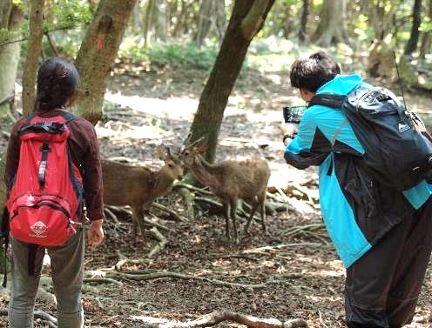 | 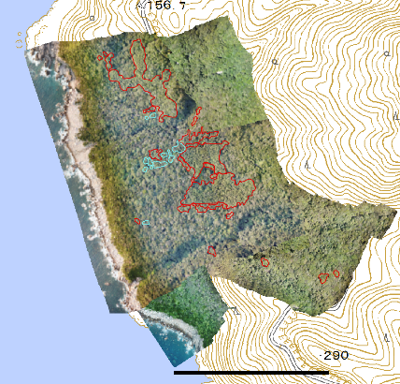 | 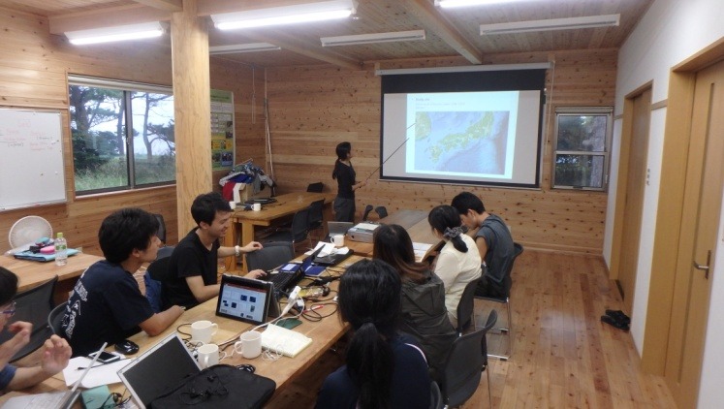
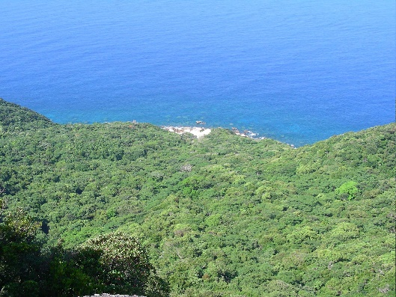 | 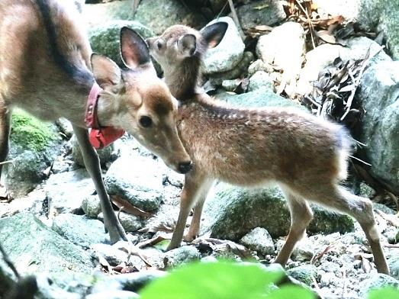 |  | 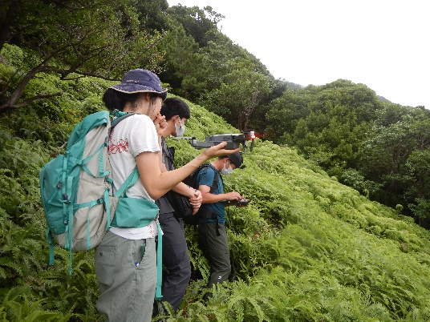

1.2 Application
Graduate students in the Division of Biological Science, Graduate School of Science, Kyoto University (as of October 1, 2021) can apply for the courses. We accept a limited number of participants (c.a. 10 students) due to the safety considerations of fieldwork and COVID-19 and limited capacity for accommodation and transportation.
We will hold the course twice this academic year, in fall (Nov 27 – Dec 3) and in winter (1 week from Feb 11-26, precise date has not been fixed yet). The contents of the fall and winter courses are different, and students may take only one of them. If an applicant was not accepted for the fall course, he/she may apply again for the winter course. In both seasons, the Advanced training in field biology will be held on Yakushima Island.
Students may apply to either the Advanced training in field biology or the Advanced laboratory skills in field biology, though we encourage you to take both courses.
Applicants must send the form before the deadline. If we have more applicants than our capacity, we will select participants within a week of the application deadline. The application form is available at the following site:
http://www.wildlife-science.org/ja/curriculum/

1.3 Credits
Participants can earn credits by taking the courses. We recommend to resister the following courses at KULASIS.
Advanced training in field biology A （野外生物学実習A） (fall course)
Advanced laboratory skills in field biology A （野外生物学分析実習A (fall course)
Advanced training in field biology B (spring course course) （野外生物学実習B）
We are planning animal census along the road and fixed points. Detailed contents will be announced later.
Advanced laboratory skills in field biology B （野外生物学分析実習B）
The contents of this course will be announced later)

1.4 Fee
Students need to pay approximately 17,000 yen for meals and insurance for the Advanced training in field biology in Yakushima on the first day. This amount will be paid back to you from the university approximately one month later.
Students must pay the costs of meals other than those provided at our field station (e.g., during travel, lunch on the first day, lunch and dinner on the last day on the way back from Yakushima), and for optional activities such as entrance fees at sightseeing spots (\300-500 / site).

2. Schedule

Advanced training in field biology A and Advanced laboratory skills in field biology A
October 8 Deadline for application
October 12 Fix the members and the courses

Nov 16 Introduction of the course, lectures on safety during fieldwork in Yakushima
Onsite: Seminar room on B1 floor of Wildlife Research Center
Online: Zoom

Advanced training in field biology A
Place: Yakushima Island, Kagoshima Prefecture
Nov 27 Advanced training in field biology starts (Move to Yakushima on this date)
(Flight schedule is not fixed)
Meeting in the evening: introduction of the lecturers and courses, etc.
Nov 28-Dec 1 Fieldwork in Yakushima
Dec 2 Data analysis, presentation in the afternoon
Dec 3 Leave Yakushima (if we have time, we will visit some places in Yakushima)
(Flight schedule is not fixed)
(Dec 4-5) Annual meeting of the Society of Yakushimaology: some lecturers stay in Yakushima and hold the event.)

Advanced laboratory skills in field biology A
Place: Wildlife Research Center, Kyoto University, Kyoto City
Dec 6-9 Image analysis, at WRC, Kyoto. Detailed schedule will be announced later

Participants must present the results of the courses at the PWS symposium in May 2022.

3. Contents of Advanced training in field biology A

3.1 Participants and staff
About 10 graduate students
About 5 teaching staff, including professors, post-docs and graduate students who study in Yakushima and/or subject species.

3.2 Groups
We make only one group this time.

Vegetation survey by done
Title
Vegetation survey by done in the natural forest in Yakushima

Lecturers
Sota Inoue (Graduate School of Environmental Studies, Nagoya Univ.)
Tamao Maeda (Wildlife Research Center, Kyoto Univ.)
Hideki Sugiura (Wildlife Research Center, Kyoto Univ.)
(We may invite some more lectures)

Abstract
In the western lowland forest of Yakushima, research on Japanese macaques and sika deer has been conducted for a long time. The forest look like homogeneous, but they actually have different logging histories and different vegetation. These vegetation differences are likely affect animal densities.
First, we would like to discriminate the artificially planted trees by the done images. Next, we would like to pick up naturally growing trees that have a characteristic shape. For example, conifers such as pine and cedar are likely to be distinguishable from the surrounding hardwoods. In addition, we would like to take on the challenge of identifying tree species at the individual level and determining the degree of fruiting of trees.
We will not only shoot with a drone, but also actually walk in the forest and see the plants from the ground.

4. Contents of Advanced laboratory skills A
We will analyze the sample collected in the Advanced training in field biology and present the results together with the field observation in the Advanced training in field biology.

Lecturers
(Graduate School of Environmental Studies, Nagoya Univ.)
Tamao Maeda (Wildlife Research Center, Kyoto Univ.)

Abstract
Further analysis will be carried out using the images taken on Yakushima. Type vegetation and perform quantitative analysis.

4.2 Reports on the past program and reports
Leading Graduate Program of Primatology and Wildlife Sciences (in English)
http://www.wildlife-science.org/en/curriculum/yakushima-field-science-course.html

5. Information on fieldwork and life in Yakushima Island

5.1. Fieldwork
Research in Yakushima
In the lowland forest, the canopy is closed and the forest floor is dark. Undergrowth is sparse in the western lowland where you can observe habituated Japanese macaques and deer. In the highland, undergrowth is dense and the summit area is densely covered with bamboo grasslands. There are no trails in the western lowland forest, but we can walk through most parts easily. We sometimes walk on steep slopes and cross streams. In other parts of Yakushima, we walk only along logging roads or existing trails for hikers. Please wear long trousers and sturdy shoes to protect your legs and feet in case you lose your balance.
During the month of November, you may get bug bites (mostly mosquitoes) and hornets are still active and aggressive. A long-sleeved shirt is good for protection from insect bites. Wear a long-sleeved shirt in particular if you have sensitive skin. We also walk on the road to search for animals and their feces. Sunlight is strong on the road, so you should also have a hat.
In the forest, visibility is poor and you need to confirm your location using a map and compass (and GPS).

Weather
Check the temperature and precipitation of Yakushima by yourself. We will go at an altitude of 500 m for vegetation survey. At the height, the temperature goes down 3 ℃ from the village. We may also visit high altitude area about 1000m A.S.L, where the temperature is 6 ℃ lower.

Wear in the field
･Long-sleeved shirt, long trousers, hat or cap
In general, it is better to wear a long-sleeved shirt and long trousers to cover your skin in the field. They will protect you from insect bites, scratches and strong sunlight. Long trousers should be soft and loose enough to walk on steep slopes. Avoid tight jeans, because they restrict movement and become heavy and hard when wet.

･Footwear
Avoid slippery shoes or those that do not completely cover your feet, such as sandals.
Mountaineering/hiking shoes/boots are best, if you have them. We recommend them, particularly if you do not have much experience walking in hilly/mountainous forests.
Jogging shoes or sneakers are good in the lowland forest, though they are not water proof and may not protect your feet in rocky terrain. They should be tough enough to walk on rocky slopes. You can rent appropriate footwear from a sport shop in Yakushima and can be reimbursed for such expenses by the university.
If you have old mountaineering shoes, jogging shoes or sneakers (more than 3 years), check their soles. Old bonds may become weak and the soles can fall apart. Almost every year, one or two participants have their soles fall apart.
High boots are also good, if you are experienced in walking in the mountains with them.
･Rainwear
Waterproof and breathable fabrics (e.g. Gore-Tex) are highly recommended. You can borrow these as well from a sport shop in Yakushima and be reimbursed for such expenses.
･Gloves
You may wear gloves if you like. Thin gloves are good for manipulation, such as taking notes, while protecting your hands and adding grip in the forest.

5.2. Accommodation and meals
In Yakushima, we stay in the field station (PWS House Yakushima) of Kyoto University in Nagata Village. All meals are provided during our stay in the field station. For dinner, you can enjoy local foods cooked by local people. Students and staff will not cook except dinner on the last night. We wash dishes and clothes and clean the rooms by ourselves.

Do it yourself in the field station
We have no housekeeper in the station. You will be responsible for maintaining the station and doing daily chores such as cleaning, washing clothes, packing lunch, washing dishes, taking out the garbage, etc. Please do these things actively and cooperatively.

Meals
Meals are cooked by a resident in Yakushima. Please help her cook when necessary. If you have food allergies or food(s) to avoid (e.g., for vegetarians), please let us know.
We pack lunches by ourselves. Bring a lunchbox of your own preference and any utensils necessary (spoon, fork, chopsticks, etc.).

Room and bedding
In the Field Station, there is a dining hall, kitchen, 3 shower rooms and 3 restrooms. You will share one of 5 bedrooms with other students (2 people / room). Each bedroom has two bunk beds with mattresses. Please bring your own sleeping bag or blanket and/or warm clothes, as the temperature may drop to 15 degrees at night and we do not have enough blankets in the station. Expensive, high-quality sleeping bags are not necessary; inexpensive ones are good enough as we stay inside the house at night.

Bath
There are three shower rooms. We prepare shampoo and soap, which you can use freely for bathing. If you prefer your own shampoo or soap, please bring them. Have your own towel for bathing.

Washing clothes
Two washing machines are available at the station. We will provide the laundry detergent. Please wash your clothes together with those of other station members to save time and avoid wasting water/electricity. We prepare mesh bags for washing, in which you can put your clothes. Do not start washing after 10 p.m. to avoid making noise and inconveniencing others.

Others
You may bring sandals, which may be useful for walking around the station.

Shopping
In Nagata Village, you can buy snacks, drinks and daily necessities at a small shop. There are no supermarkets or convenience stores in the village. There is a supermarket in Miyanoura (20 km from the field station), the largest town in Yakushima Island, but you may not have time to go shopping there, except on the last day.

5.2. List of personal equipment
Equipment for field research (common to all groups)
In addition to below, some other equipment will be necessary depending on your activity. Special equipment in each group will be announced later.

□ backpack (20-30 litters is enough)
□ notebook (pocket size is good)
□ pen / pencil
□ marker (with which you can write on plastic sample bags and plastic tubes)
□ canteen (you may use a PET bottle)
□ lunch box and spoon, fork, chopstick (bring a plastic container to pack your lunch to Yakushima)
□ flashlight (and batteries)
□ whistle (we can lend some whistles. Please let us know if you do not have it)
□ sampling bag, tube, etc. (they are given to participants at Yakushima)
□ maps (they are given to participants at Yakushima or Kyoto)
□ poison remover (they are given to participants at Yakushima)
□ backpack cover, or plastic bag inside the backpack (optional, when it is rainy)

□ long trousers (and a belt, must)
□ socks (must)
□ rainwear / umbrella (when it is rainy)

□ insect repellent (optional)
□ antipruritic (optional)
□ sunscreen (optional)
□ snack, candy, etc. (optional)
□ adhesive tape (optional, each lecturer has a first-aid kit)
□ towel (optional)
□ tissue (optional)

□ vest (optional)
□ waist pouch (optional)
□ spats optional)
□ gloves (optional)

□ camera (optional)

Other things for stay at the field station
□ sleeping bag or blanket (must).
□ underwear
□ clothes (which you can wear in the house)
□ sandals (optional)
□ towel
□ toilet kit
□ laptop (optional; a personal laptop computer is useful for data analysis and presentation of the results)

